**AF-S NIKKOR 50mm f/1.8G**

**Key Features**

* 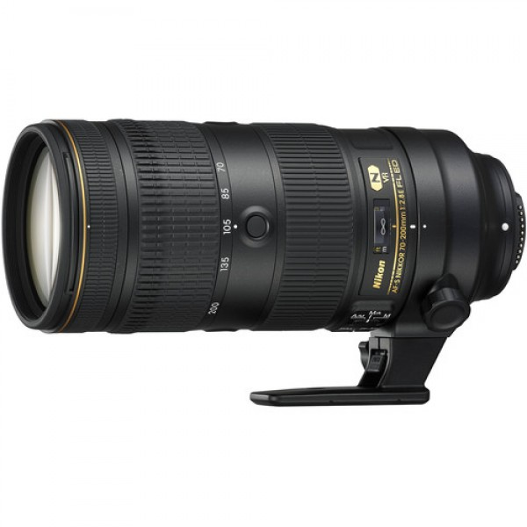A fast, single-focal-length lens with normal 50mm focal length
* Large maximum aperture of f/1.8
* Newly developed optical system employing an aspherical lens element
* Silent Wave Motor (SWM) realizes quiet AF operation
* Two focus modes are available — M/A (quick switching from AF to MF) and M (manual focus)

Specifications

|  |  |
| --- | --- |
| Focal length | 50mm |
| Focal length | 50mm |
| Maximum aperture | f/1.8 |
| Minimum aperture | f/16 |
| Lens construction | 7 elements in 6 groups (with one aspherical lens element) |
| Angle of view | 47° (31°30' with Nikon DX format) |
| Minimum focus distance | 0.45 m/1.48 ft |
| Maximum reproduction ratio | 0.15x |
| No. of diaphragm blades | 7 (rounded) |
| Filter-attachment size | 58mm |
| Diameter x length (extension from lens mount) | Approximately 72 x 52.5 mm/2.8 x 2.1 in. |
| Weight | Approximately 185 g/6.6 oz |
| Supplied accessories | 58mm snap-on Front Lens Cap LC-58, Rear Lens Cap LF-4, Bayonet Hood HB-47, Flexible Lens Pouch CL-1013 |